Image Harvest

1. Installation
2. The Application

Installation:

1. For Windows
2. Go to the official [Python download page for Windows](https://www.python.org/downloads/windows/).
3. Download the Python 3 release

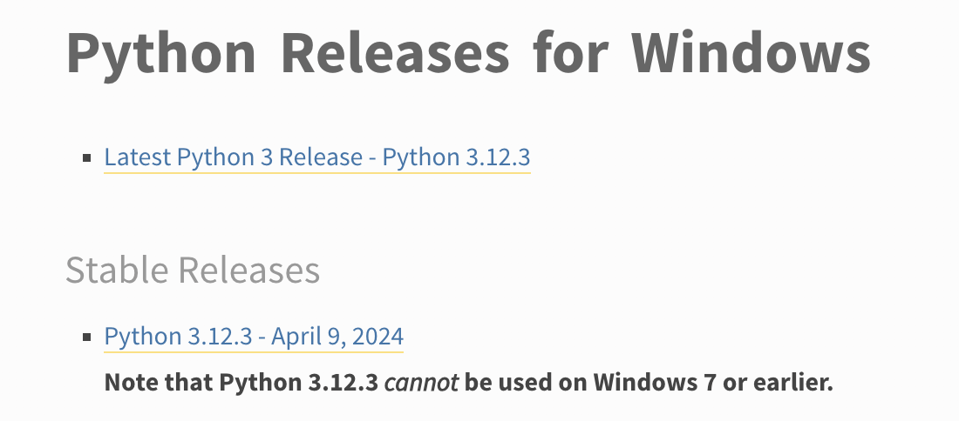

1. Run the executable installer. For more info refer to the link above.
2. Download the Image Harvest Link [here](https://github.com/N-Compass-TV/image-harvest)
3. Go to Windows and execute the Install-Package.bat
4. Input **credentials** in credentials.py
5. Run Image Harvest

B. For Mac

1. Using Installer
2. Go to the official [Python download page for Mac](https://www.python.org/downloads/macos/)
3. Run the installer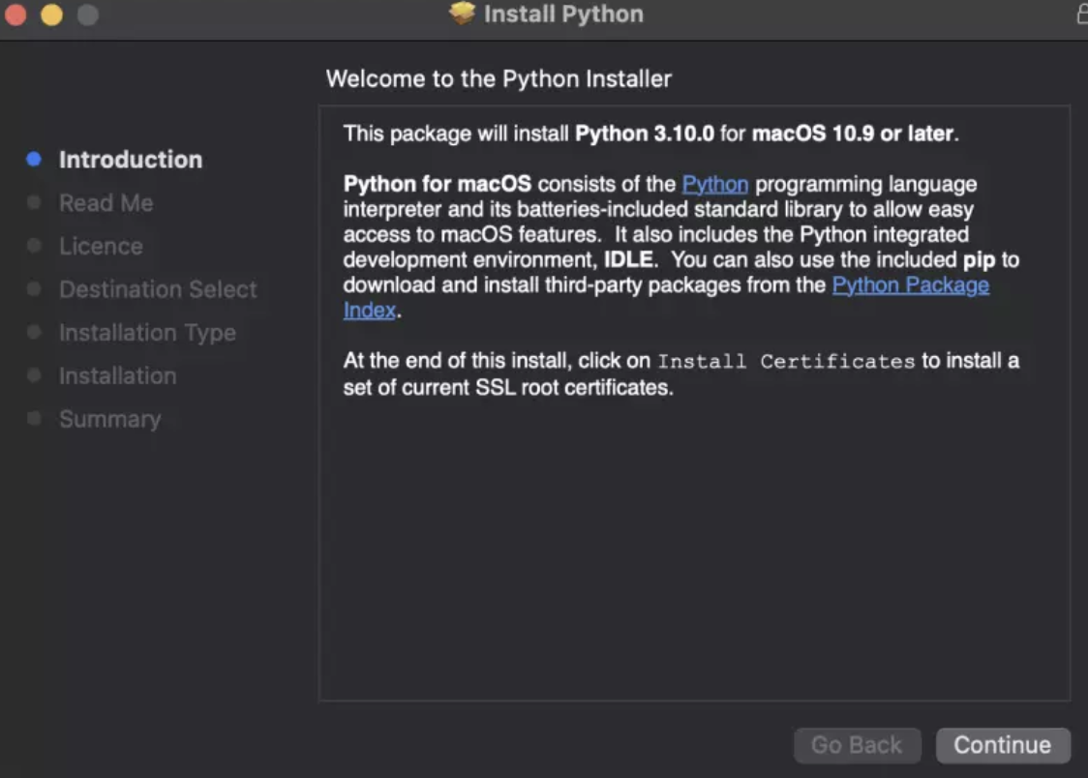

II. Using homebrew

1. Go to your terminal
2. Install homebrew by executing this command

/bin/bash -c "$(curl -fsSL https://raw.githubusercontent.com/Homebrew/install/HEAD/install.sh)"

1. Input your password
2. Execute this command

brew install pyenv

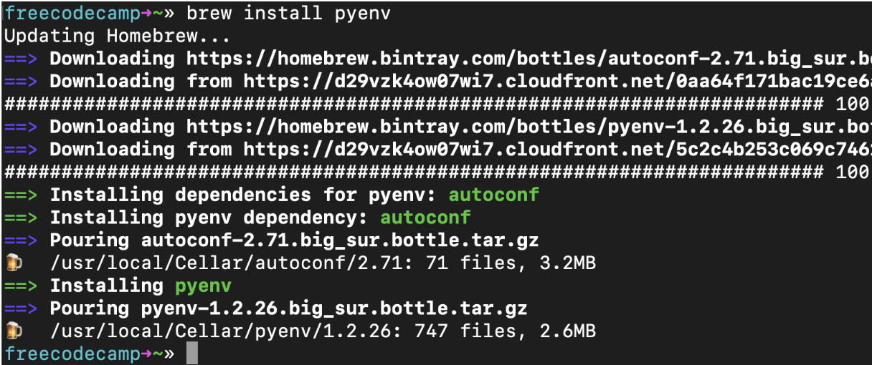

1. Run this command to update python

pyenv install 3.9.2

**Image Harvest**

1. Copy the desired URL of the website you need to scrape

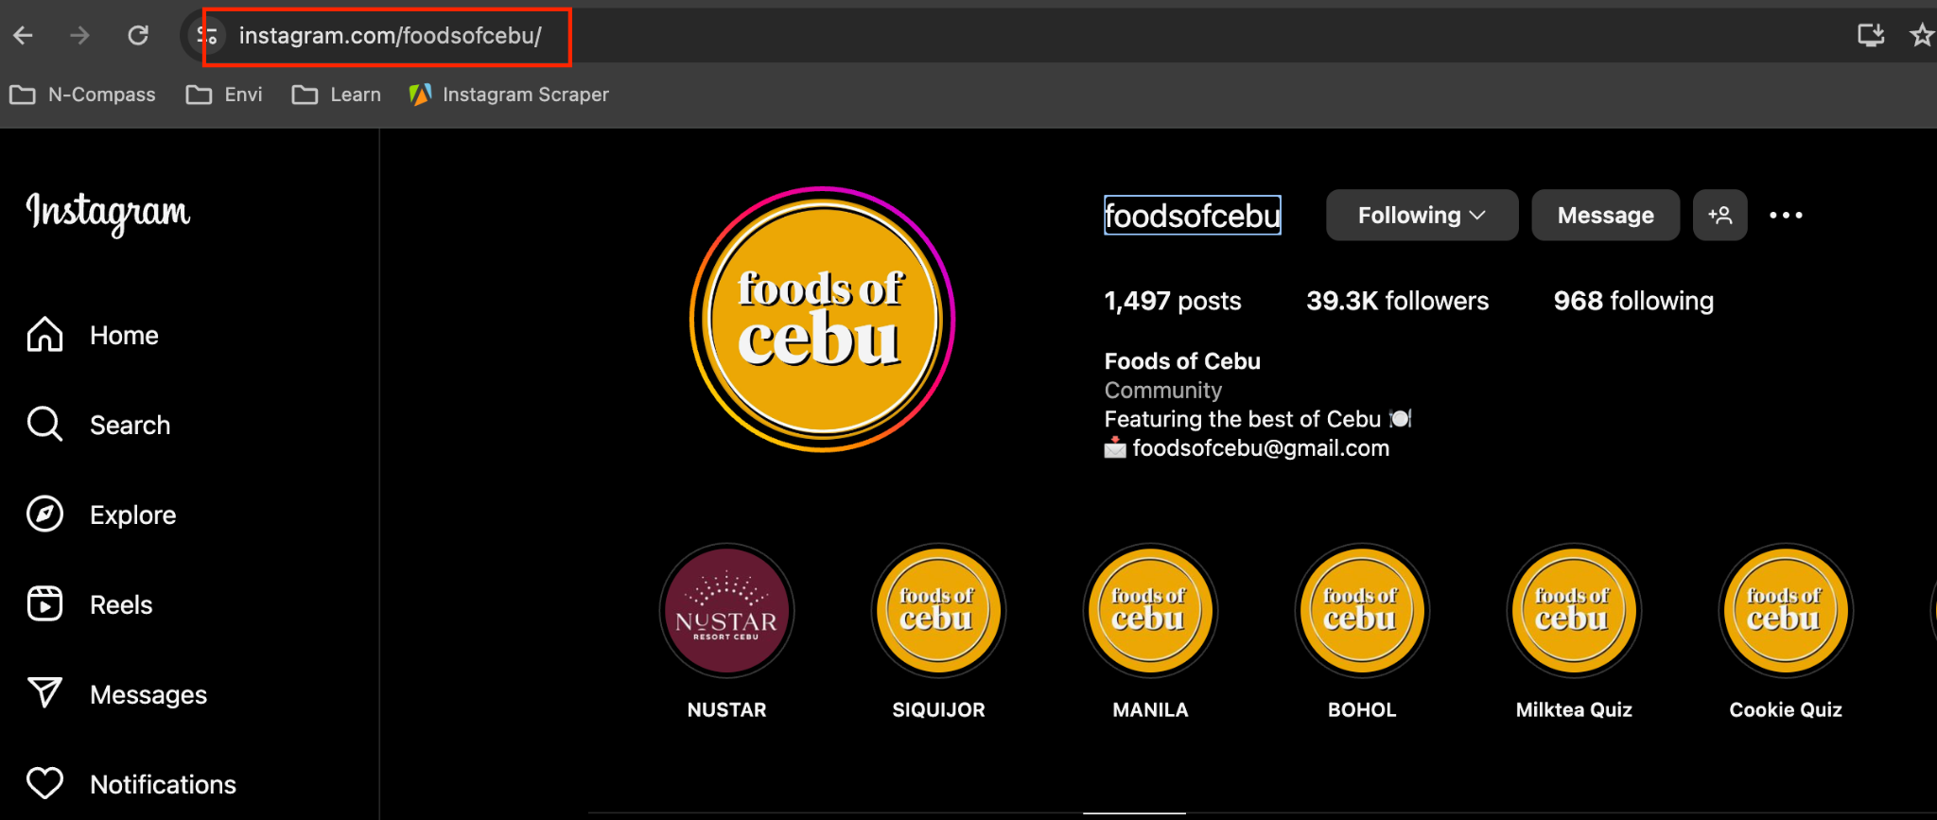

1. Go to Image Harvest
2. Enter the URL

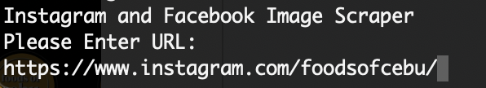

1. Enter Max Image to scrape: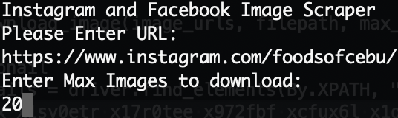
2. Wait for the image to be downloaded
3. Images are downloaded into their respective folders